**Configure Git on your windows**.

**Step 1:**

Install <https://git-scm.com/download/win>

**Step 2:**

Open Git Bash.

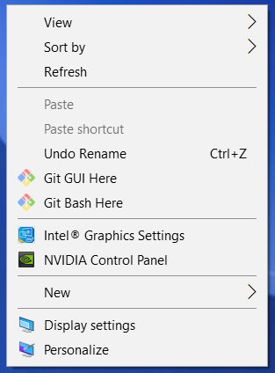

**Step 3:**

Change the current working directory to your local project.

Initialize the local directory as a Git repository.

git init

**Step 4:**

Clone your git repository to local file system.

git clone <repo-url>

**Step 5:**

Add the files in your new local repository. This stages them for the first commit.

git add .

**Step 6:**

Commit the files that you've staged in your local repository.

git commit -m "First commit"

Step 7:

[Push the changes](https://help.github.com/articles/pushing-to-a-remote) in your local repository to GitHub.

git push origin master